* If an observation has a missing value or a nonpositive value for the [WEIGHT](https://support.sas.com/documentation/cdl/en/statug/63962/HTML/default/statug_surveylogistic_a0000000368.htm) or [FREQ](https://support.sas.com/documentation/cdl/en/statug/63962/HTML/default/statug_surveylogistic_sect012.htm) variable, then that observation is excluded from the analysis.
* Observations with no effect on variable are set to missing. While, who did that were set to 1 and who did not are 2.

Eg. Did u drink and drive?

1. I don’t drive
2. Drank and drive
3. Didn’t drive when drunk

* Target – seriously consider attempting suicide Q26

************building logistic regression for each category**************

**Unintentional injury and violence** 🡪 built on variables from qn8 to qn25.

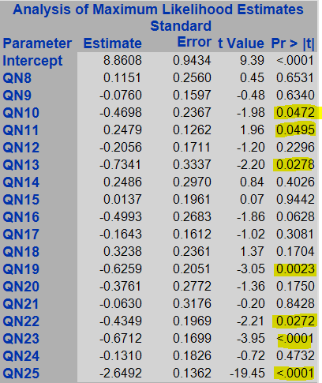

The model showed that qn10,qn11,qn13,qn19,qn22,qn23,qn25 are significantly explaining the target from this category.

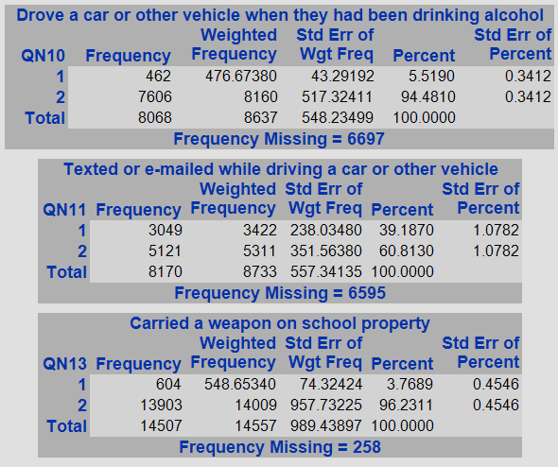 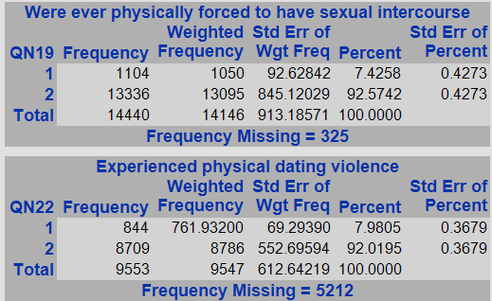

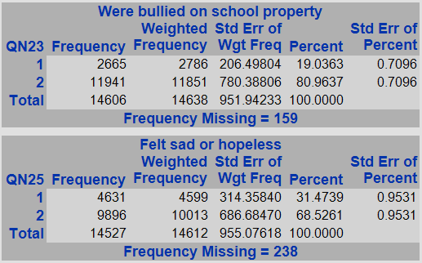

Qn10,13,19,22 are less than 90-10% distribution. So,were neglected from analysis.

The selected variables from the unintentional injury and violence category are: q11,q23,q25.

Q11- texted or emailed while driving a car or other

Q23 – were bullied on school property

Q25 – felt sad or hopeless

**Tobacco Use:** Q30-39

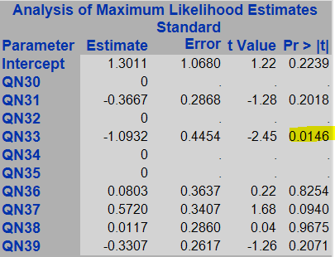

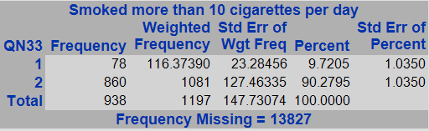

Only qn 33 is significant in this category, but it is having many missing values.

**Electronic vape : qn33-34**

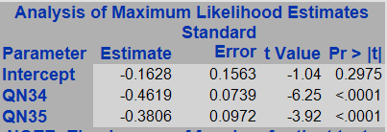

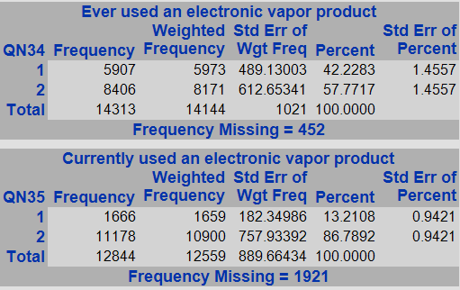

both qn33,34 are significant and having good distributions as well.

**Alcohol and other drug use: qn40-58**

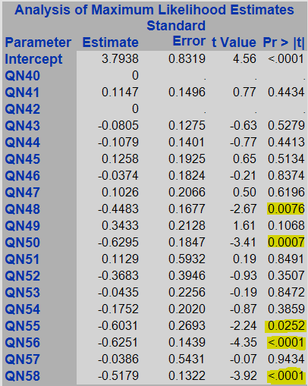

The significant variables are: qn48, qn50, qn55, qn56, qn58

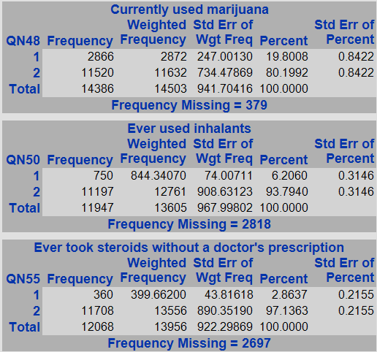

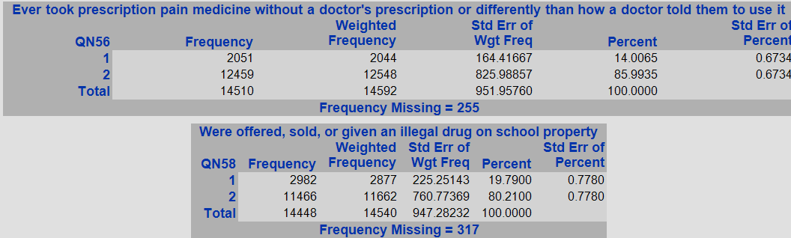

The variables which are significant and having good distribution are: qn 48, qn56, qn 58.

Qn48 – current marijuana use

Qn 56 – ever took prescription without doctor’s prescription

Qn58 – illegal drugs on school property

**Sexual behavior**: qn59-67

Question 66,67 are totally missing so removed them from model

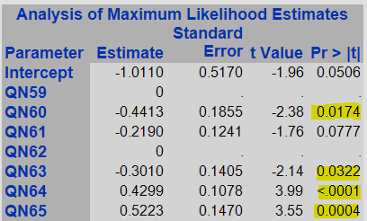

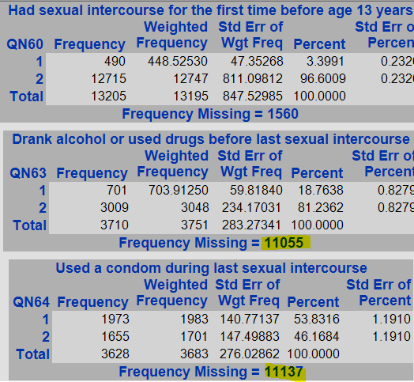 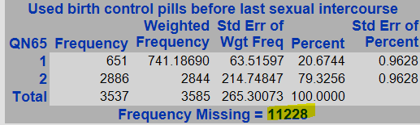

All variables doesnot look good.

**Weight management:** qn 68-69

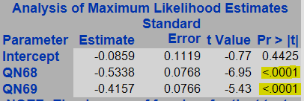 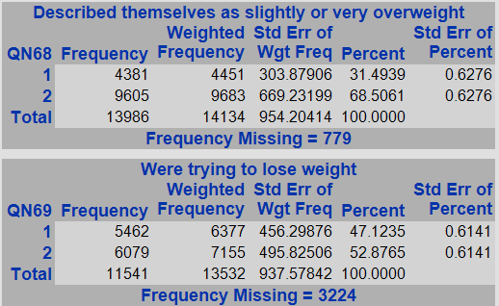

Both variables are significant with good distribution

**Dietary behaviours:** qn70-78

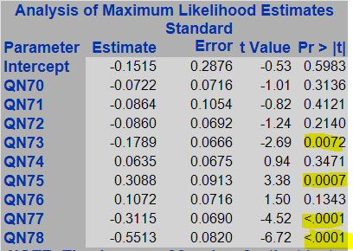

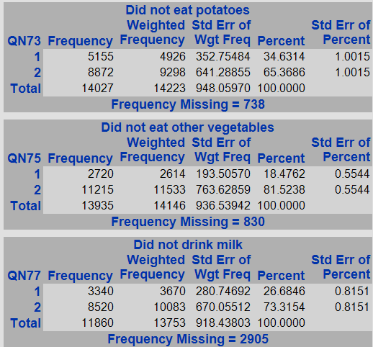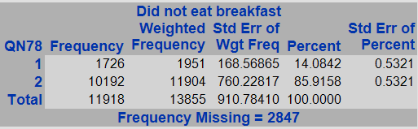

Qn 73,75,77,78 are significant with good distribution

**Physical activity:** qn79-84

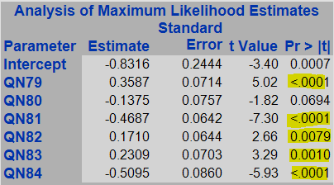

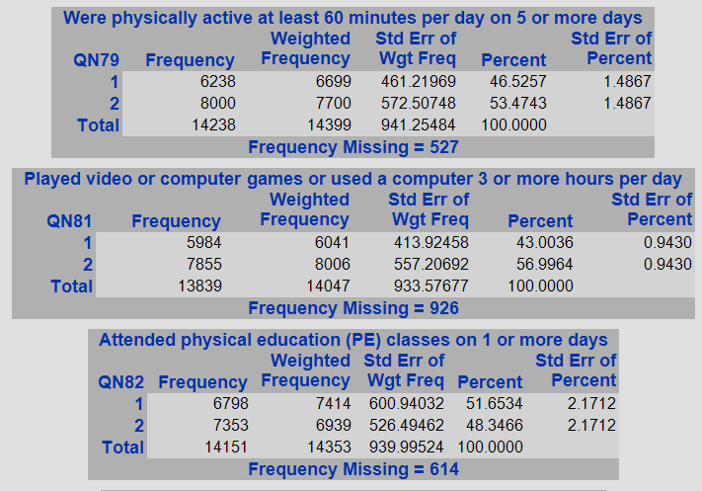 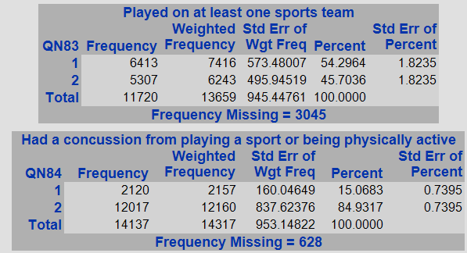

Variables qn79,qn81,qn82,qn83,qn84 are significant and good distribution

**Other topics+physcal activity:** qn85-89

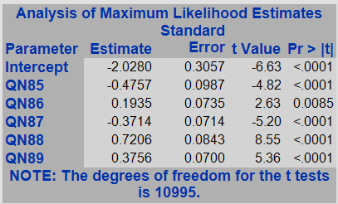 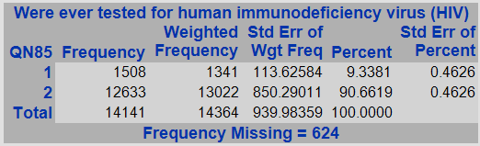

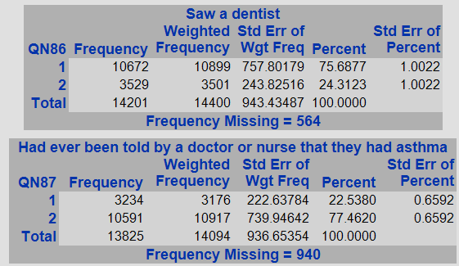 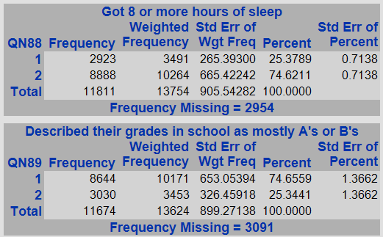

All the 85-89 questions are significant and are evenly ditributed

**Other topics: qn 92,93,98,99**

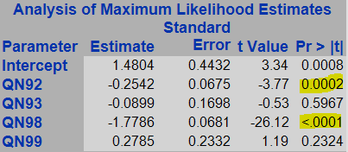

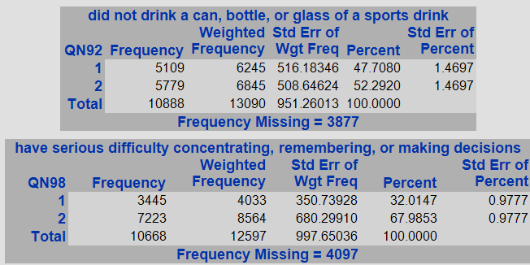

qn 92,98 are good in this category.

|  |  |
| --- | --- |
| Category | Questions |
| **Unintentional injury and violence** | Q11- texted or emailed while driving a car or other  Q23 – were bullied on school property  Q25 – felt sad or hopeless |
| **Tobacco Use** | No significant |
| **Electronic vape** | Qn33-ever used electronic vape  Qn34-currently using electronic vape |
| **Alcohol and other drug use** | Qn48 – current marijuana use  Qn 56 – ever took prescription without doctor’s prescription  Qn58 – illegal drugs on school property |
| **Sexual behavior** | No significant |
| **Weight management** | qn 68-describing themselves as over/under weight  qn69-trying to loose weight |
| **Dietary behaviours** | qn73- eat potaoes  qn75- eat other vegetables  qn77- drink milk  qn78-eat breakfast |
| **Physical activity** | qn79-physcically active  qn81- play video games  qn82-attend PE classes  qn83-part of sports team  qn84-had concussion |
| **Other topics** | Qn86-saw a dentist  Qn87-tested for asthma  Qn88-8 hours of sleep  Qn89-A or B grades  Qn92- can/soda consumption  Qn98-mental problems |